**ONLINE MOVIE TICKET BOOKING SYSTEM**

PROJECT DICUMENT

V.KEERTHANA

**PROBLEM STATEMNET:**

The "Online Movie Ticket Booking" system aims to automate the movie ticket booking process, providing a convenient and efficient alternative to manual bookings. It offers real-time movie listings, showtime, and seat selection for customers.

**PROBLEM FUNCTIONALITIES:**

The Online Movie Ticket Booking should meet the following requirements:

1. Display cities with selected theatres.

2. Manage multiple halls in each theatre, with one movie show per hall at a time.

3. Organize multiple shows for each movie.

4. Allow customers to search for movies based on title, language, genre, theatre, and city.

5. Provide theatre and showtime details for selected movies.

6. Enable customers to select a show, choose seats, and book tickets.

7. Show the seating arrangement, indicating available and booked seats.

8. Offer multiple payment options: credit/debit cards, cash, or UPI.

**MODULES IDENTIFIED:**

1. Administrator:

• Login: Secure access to the administrator's account.

• Movie Management:

o AddMovie: Add new movie details or release information.

o UpdateMovie: Modify movie details for specific theatres.

o DeleteMovie: Remove movies from the system.

• Profile Management:

o Registration: Register the administrator.

o Update: Update personal details.

• Report Management:

o Movie Details: Retrieve the list of currently running movies.

o Customer Details: Obtain a list of registered customers.

2. Customer:

• Login: Secure access to the customer's account.

• Profile Module:

o Registration: Register as a customer for ticket booking.

o Update: Modify personal details.

o View: View personal details.

• Booking Module:

o Book Tickets: Allow customers to book movie tickets online.

o View Movie List: Display the list of available movies.

o Search Movie: Help customers search for specific movies.

o Cancel Tickets: Enable customers to cancel booked tickets.

• Payment Module:

o Credit/Debit Card: Facilitate payment through credit/debit cards.

o Cash: Allow payment at the theatre to the officer.

o UPI: Offer UPI payment option.

4. Guest:

• Search for a Movie: Enable unregistered users to search and view the movie list.

**USER ROLES IN MODULES:**

**USER:ADMINISTRATOR**// First Level Of Priority

• **Login:** Secure access to the administrator's account.

• **Movie Management:**

o Add Movie: Add new movie details or release information.

o Update Movie: Modify movie details for specific theaters.

o Delete Movie: Remove movies from the system.

**• Profile Management:**

o Registration: Register the administrator.

o Update: Update personal details.

**• Report Management:**

o Movie Details: Retrieve the list of currently running movies.

o Customer Details: Obtain a list of registered customers.

**USER:CUSTOMER**//Second Level Of Priority

* **Login:**

Secure access to the customer's account.

**• Profile Module:**

o Registration: Register as a customer for ticket booking.

o Update: Modify personal details.

o View: View personal details.

• **Booking Module:**

o Book Tickets: Allow customers to book movie tickets online.

o View Movie List: Display the list of available movies.

o Search Movie: Help customers search for specific movies.

o Cancel Tickets: Enable customers to cancel booked tickets.

• **Payment Module:**

o Credit/Debit Card: Facilitate payment through credit/debit cards.

o Cash: Allow payment at the theatre to the officer.

o UPI: Offer UPI payment option.

**USER:GUEST**// Third Level Of Priority

* **Guest:**

• Search for a Movie: Enable unregistered users to search and view the movie list.

**MIND MAP:**

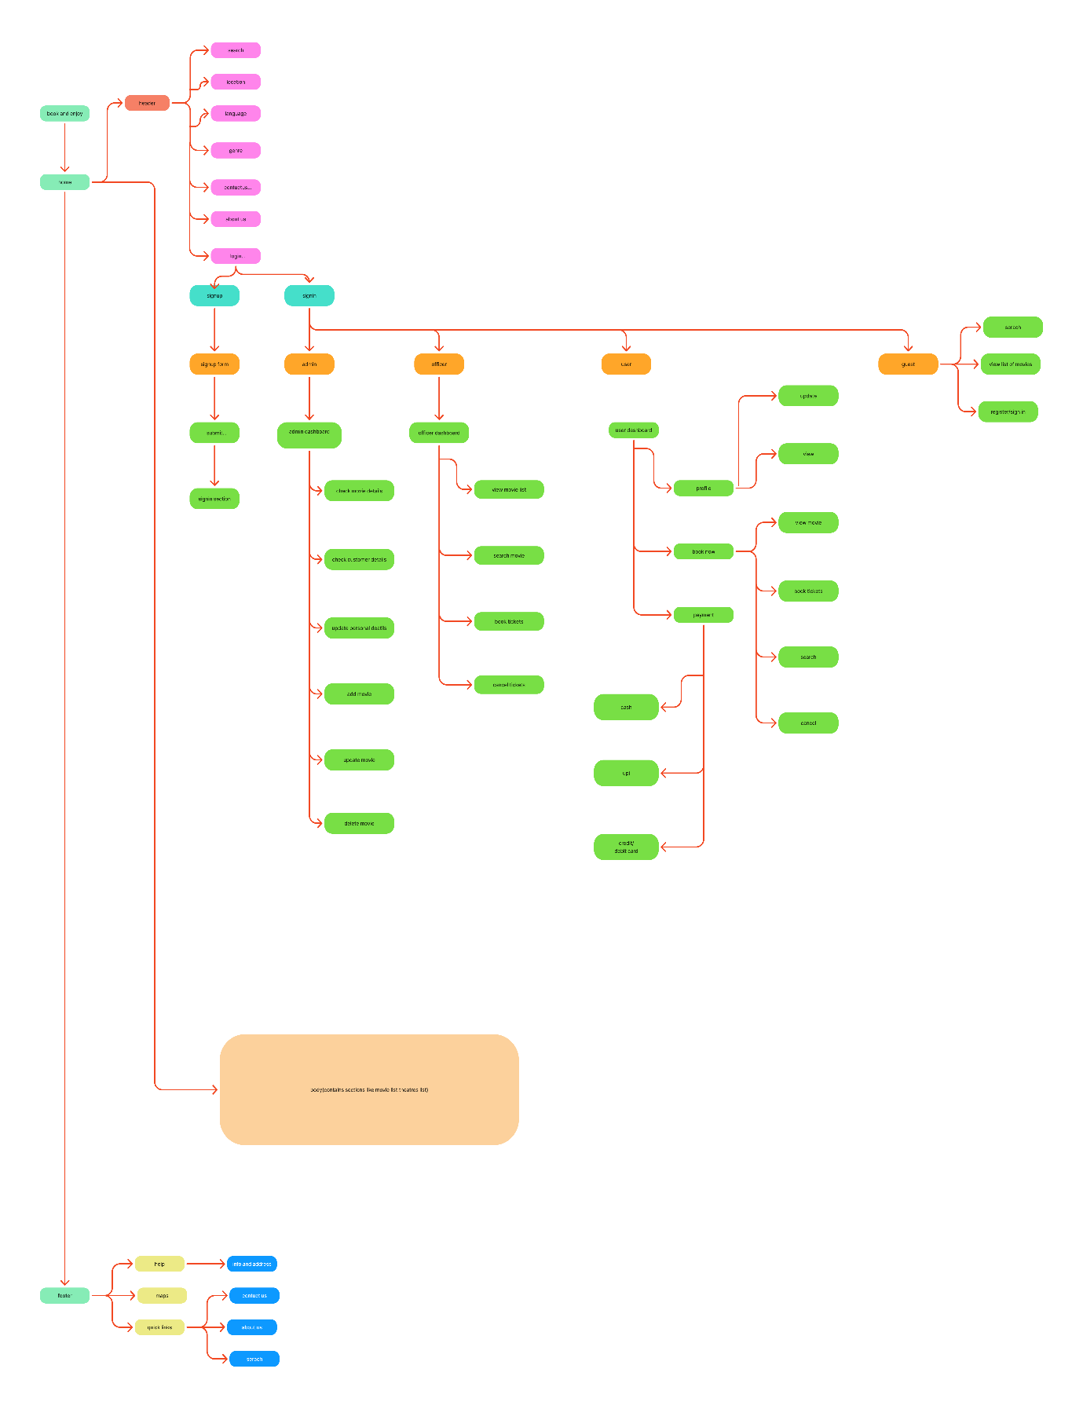

**WIRE FRAME:**

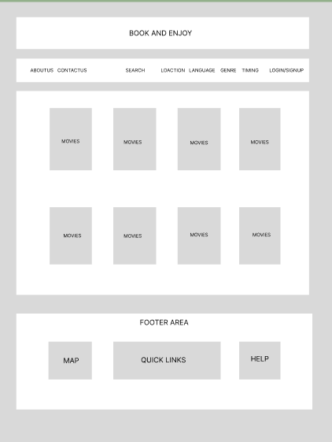**USER DASHBOARD :**

**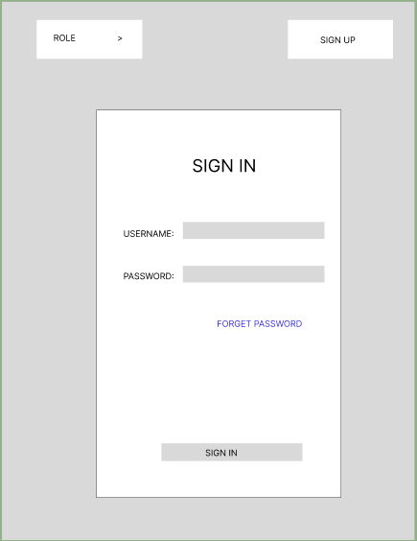  
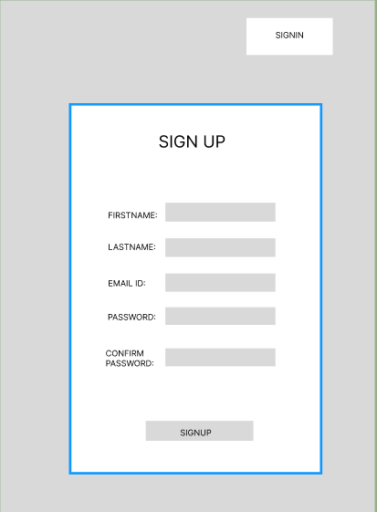**  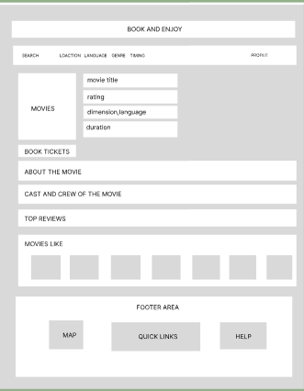

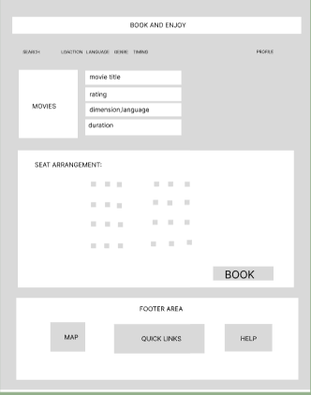 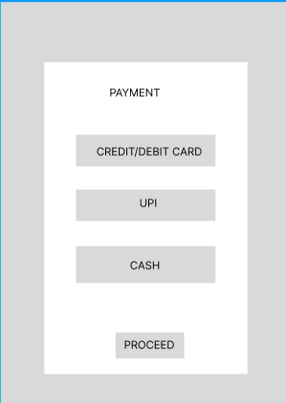

**ADMIN DASHBOARD:**

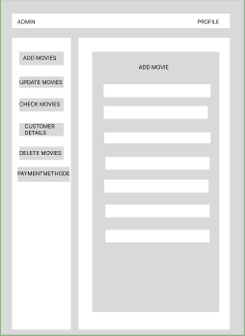 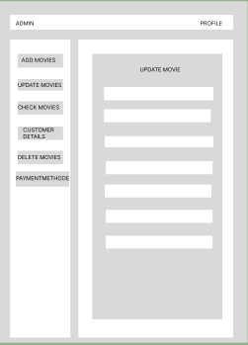

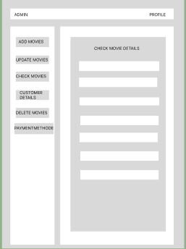 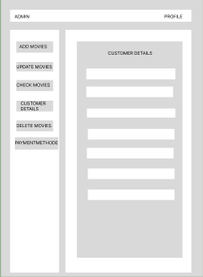

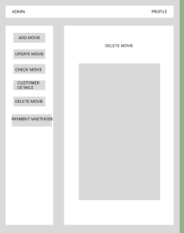 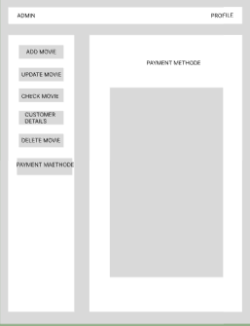

**CODE:**

**HTML:**

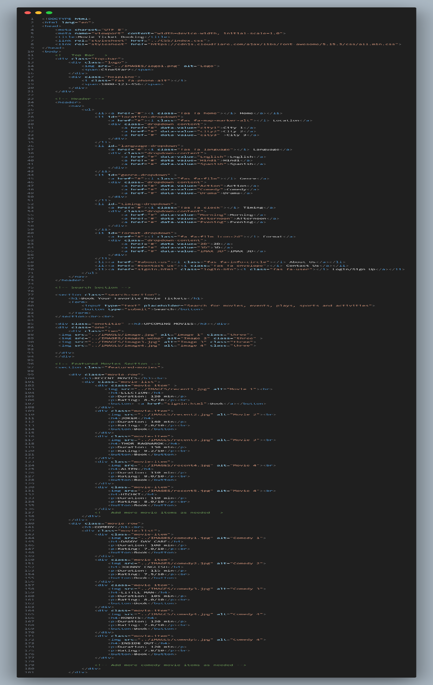

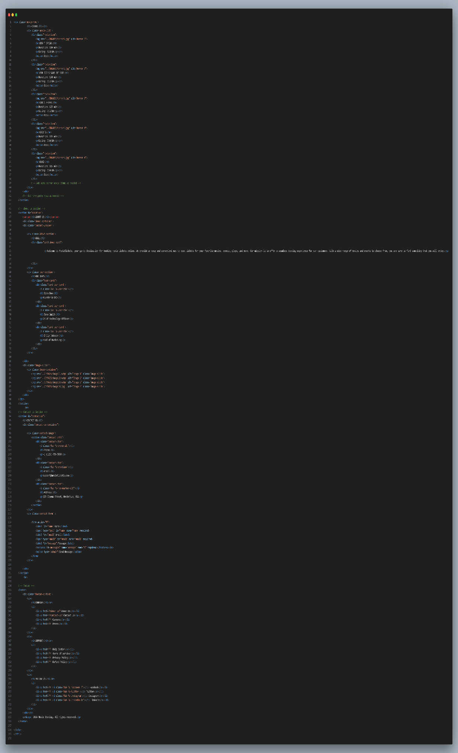

**CSS:**

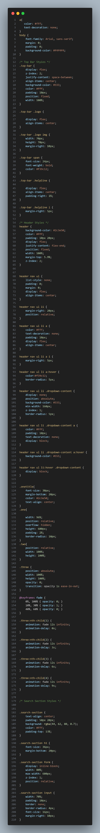

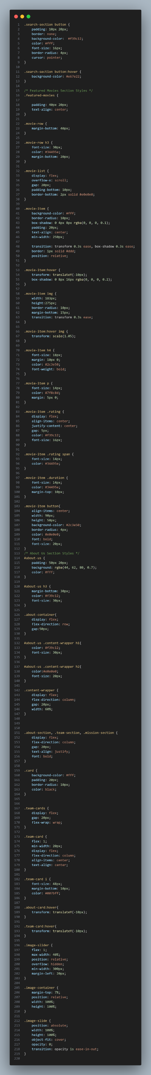

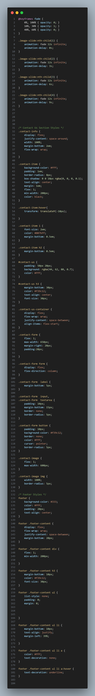

**OUTPUTS:**

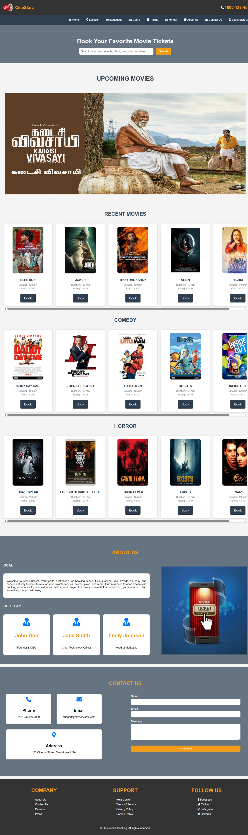

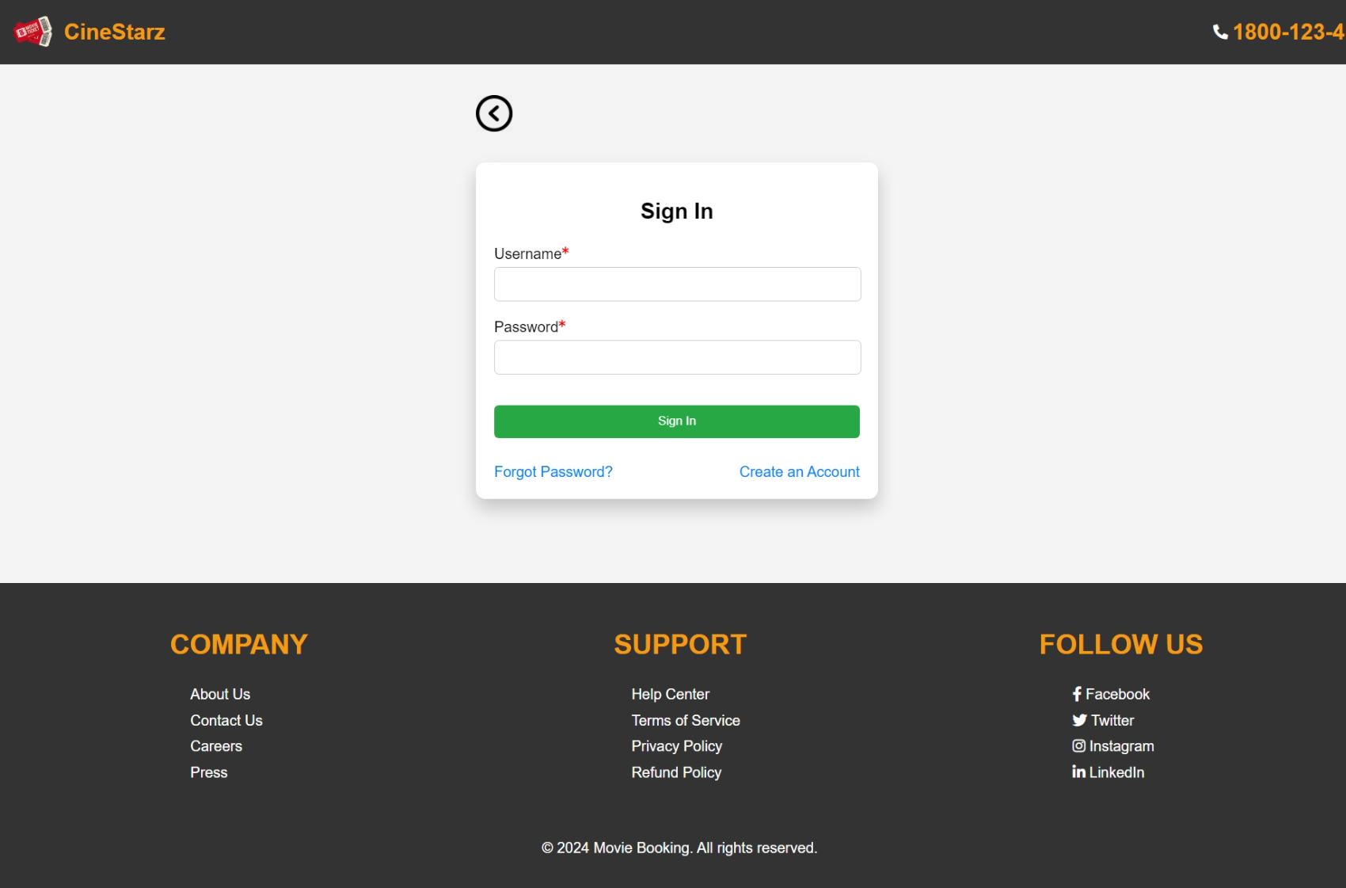

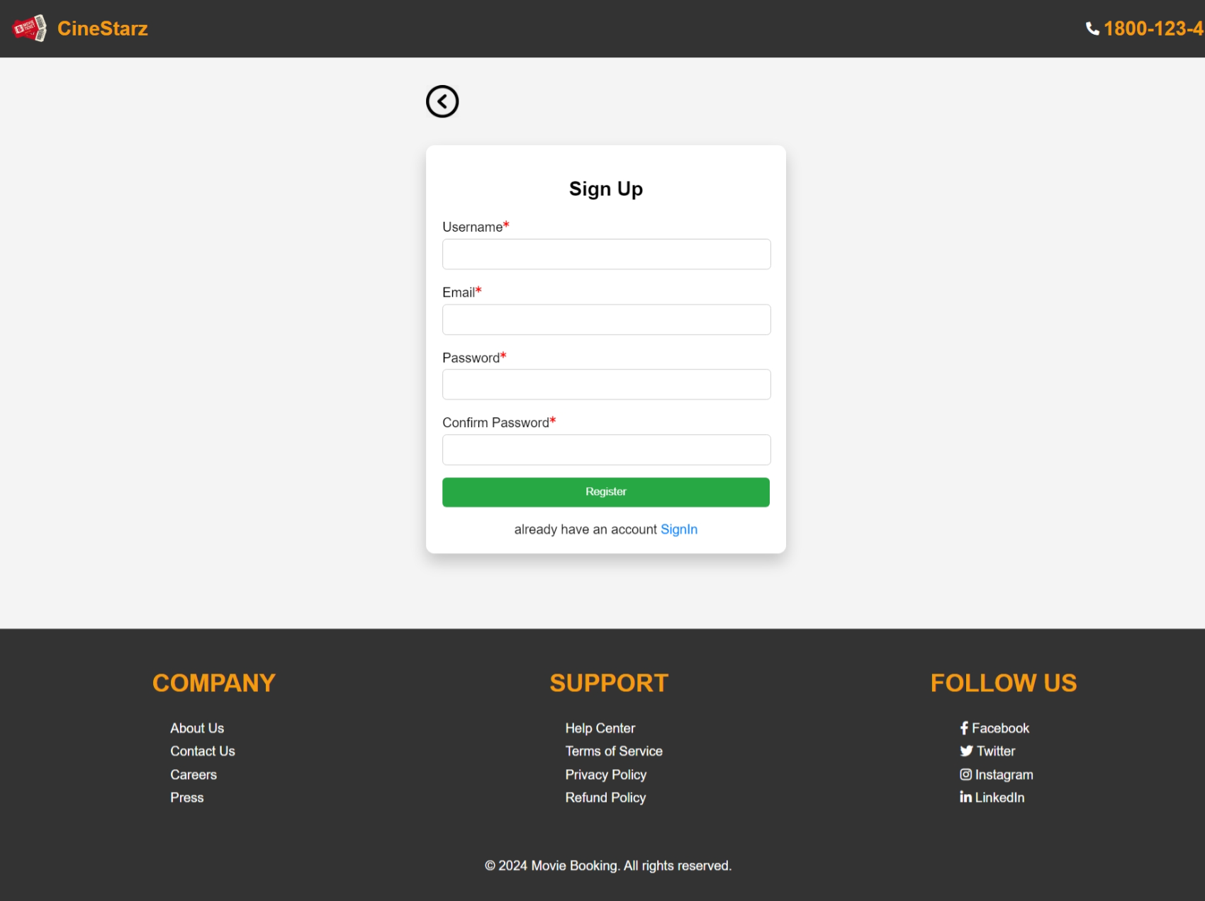

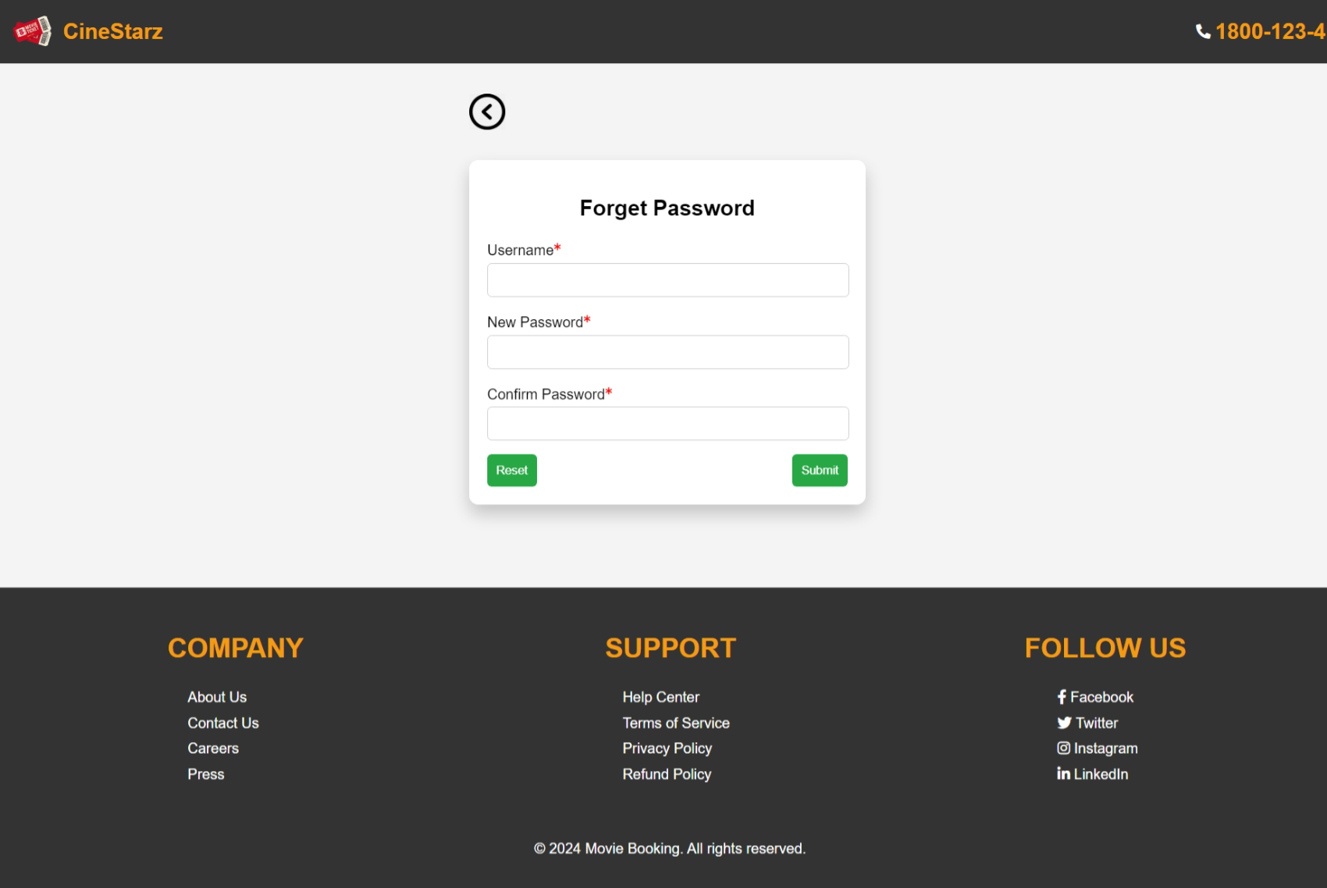

**ADMIN DASHBOARD:**

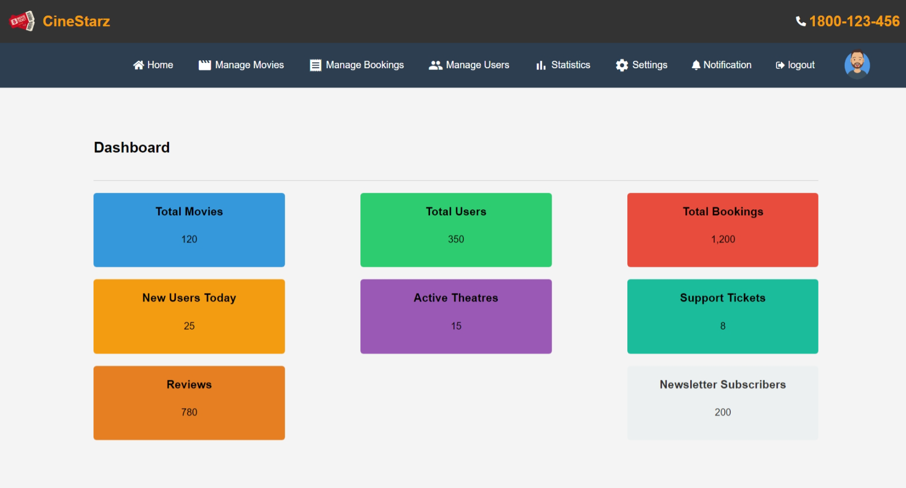

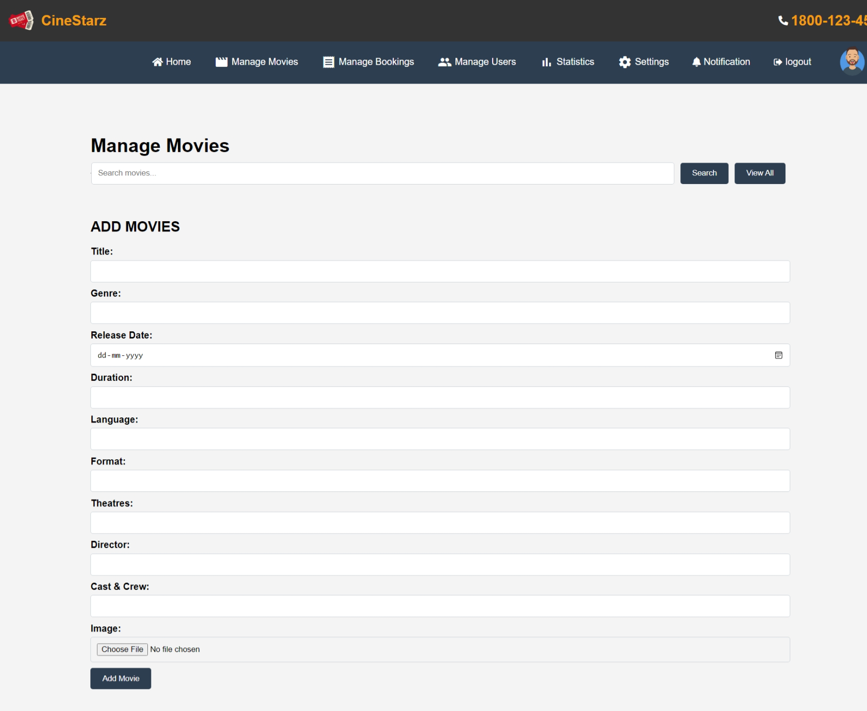

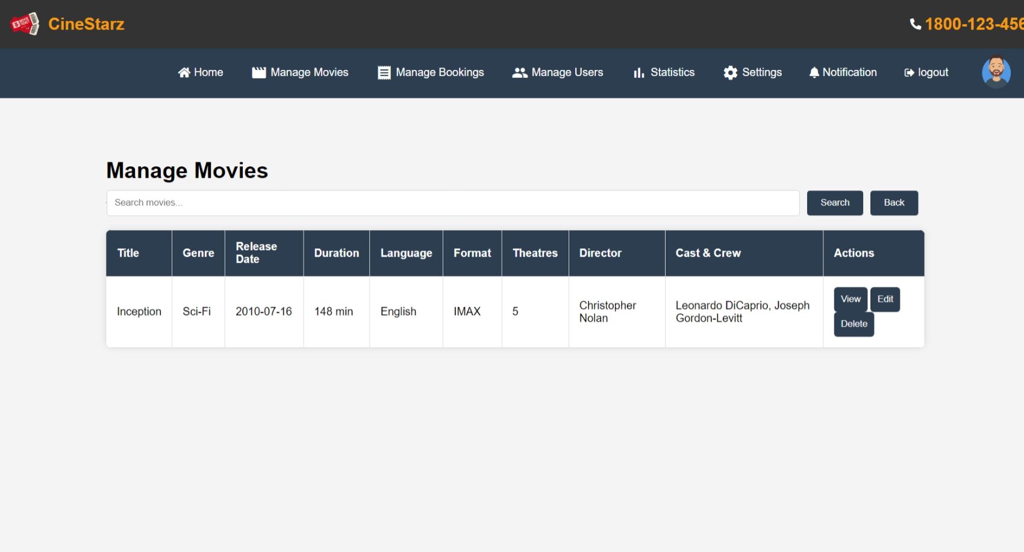

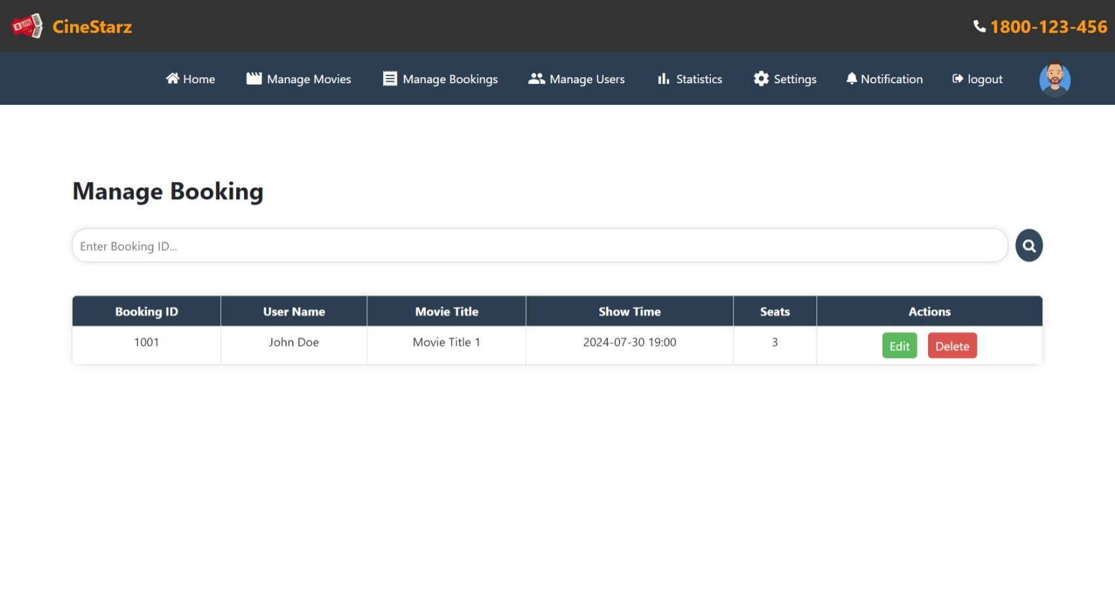

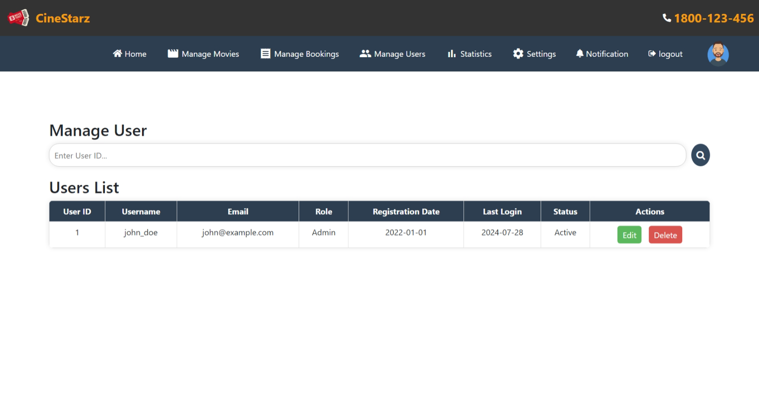

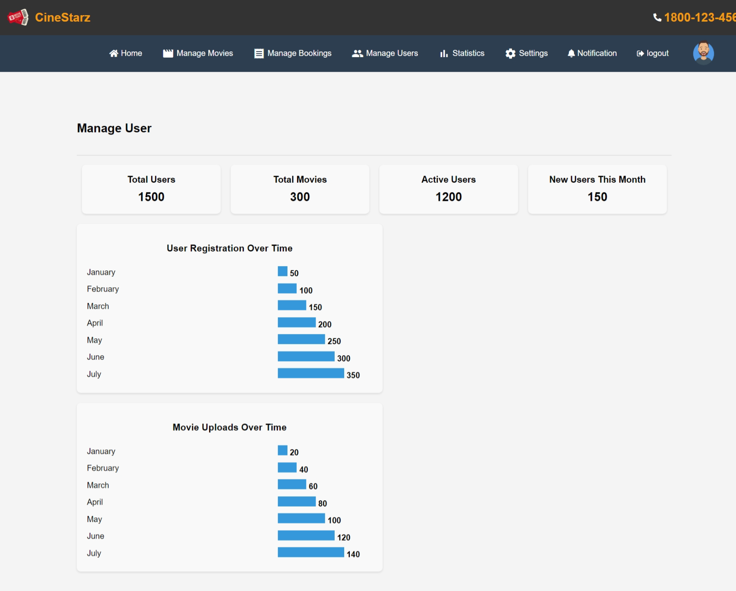

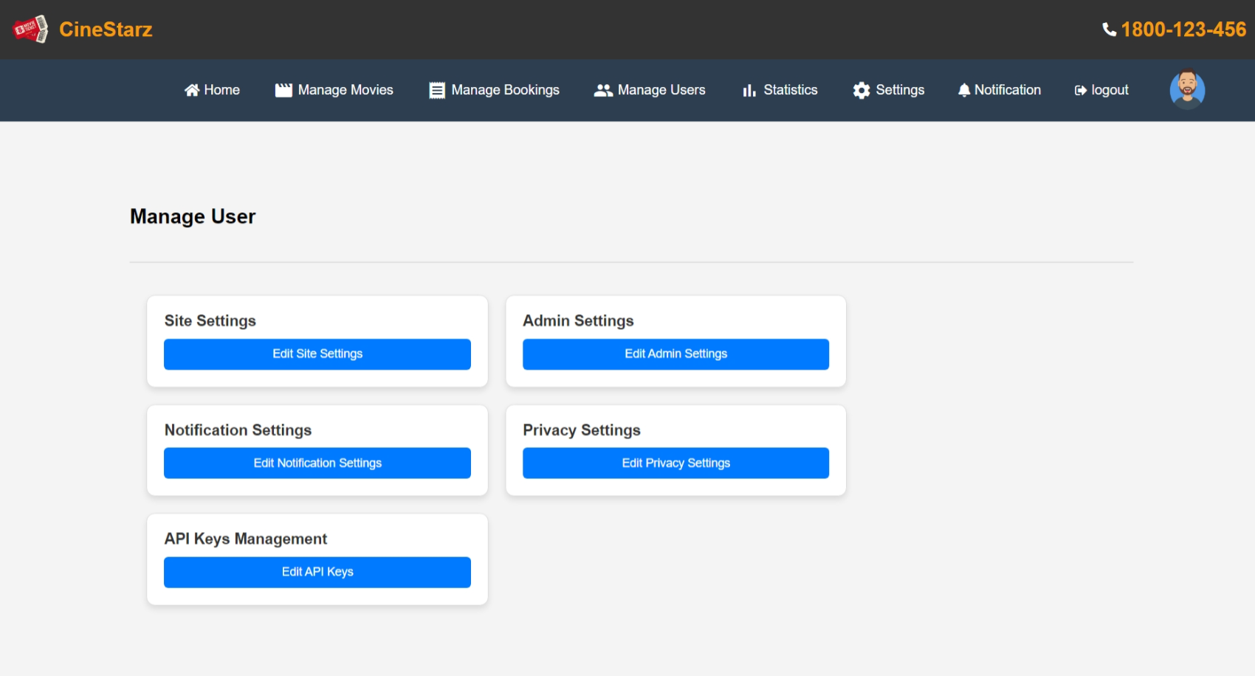

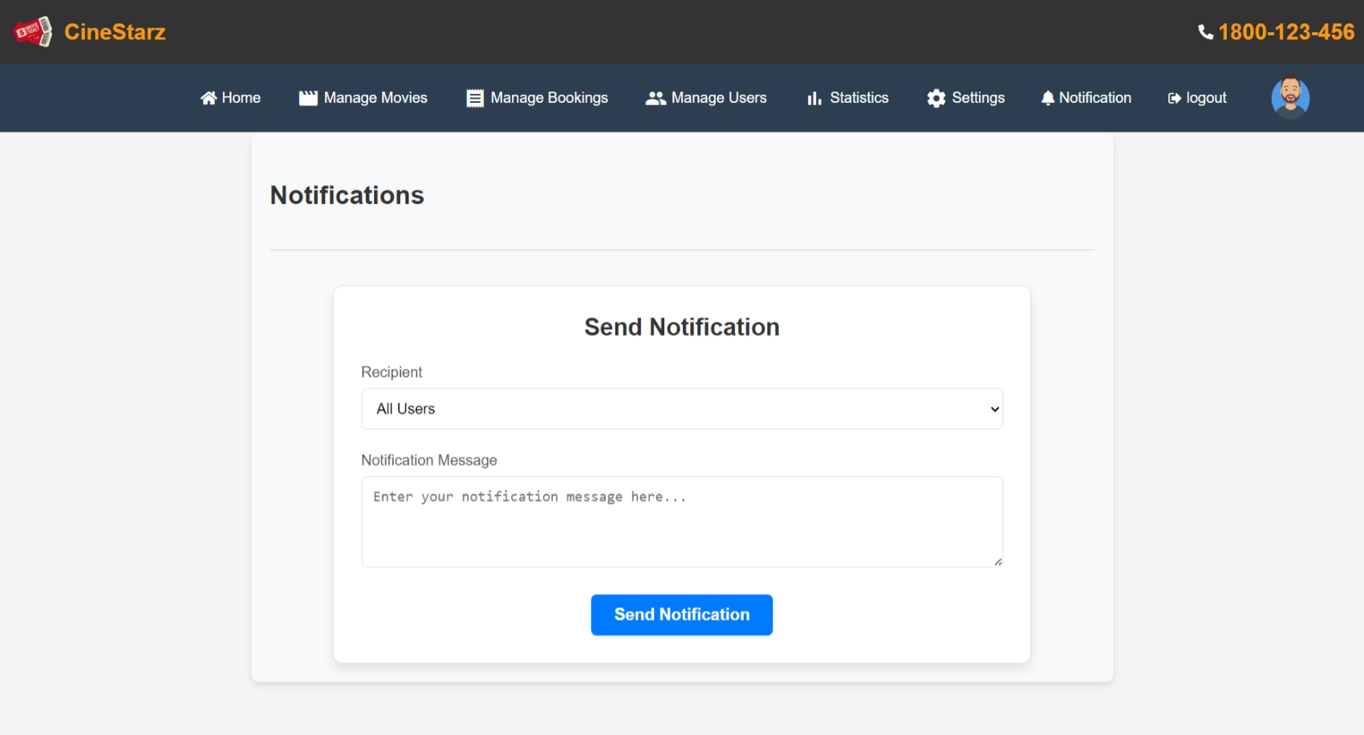

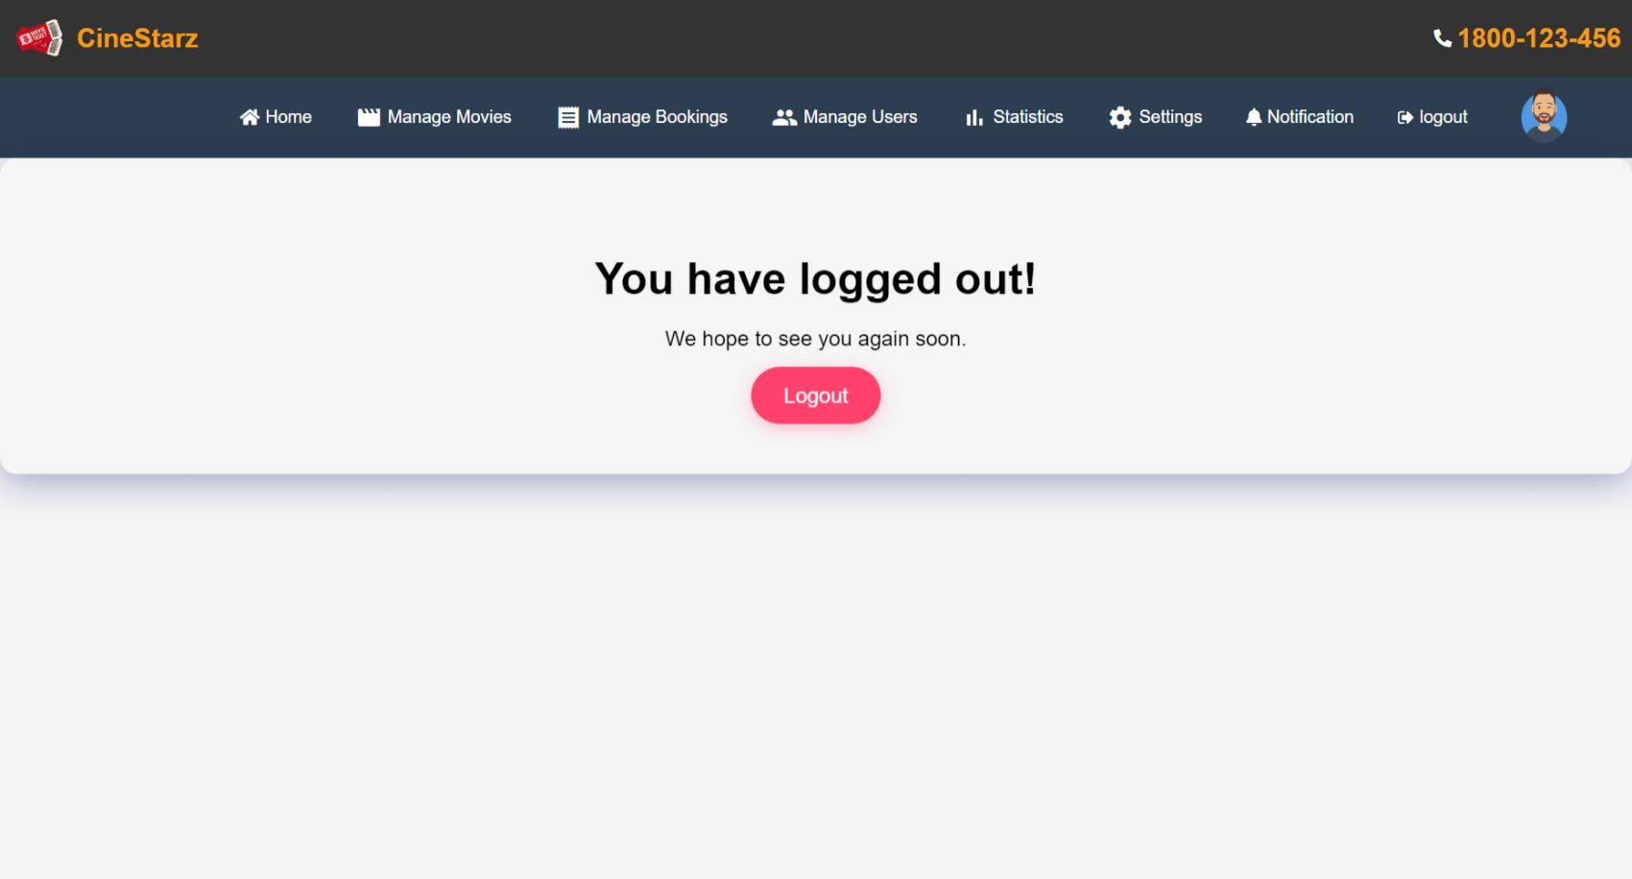

**USER DASHBOARD:**

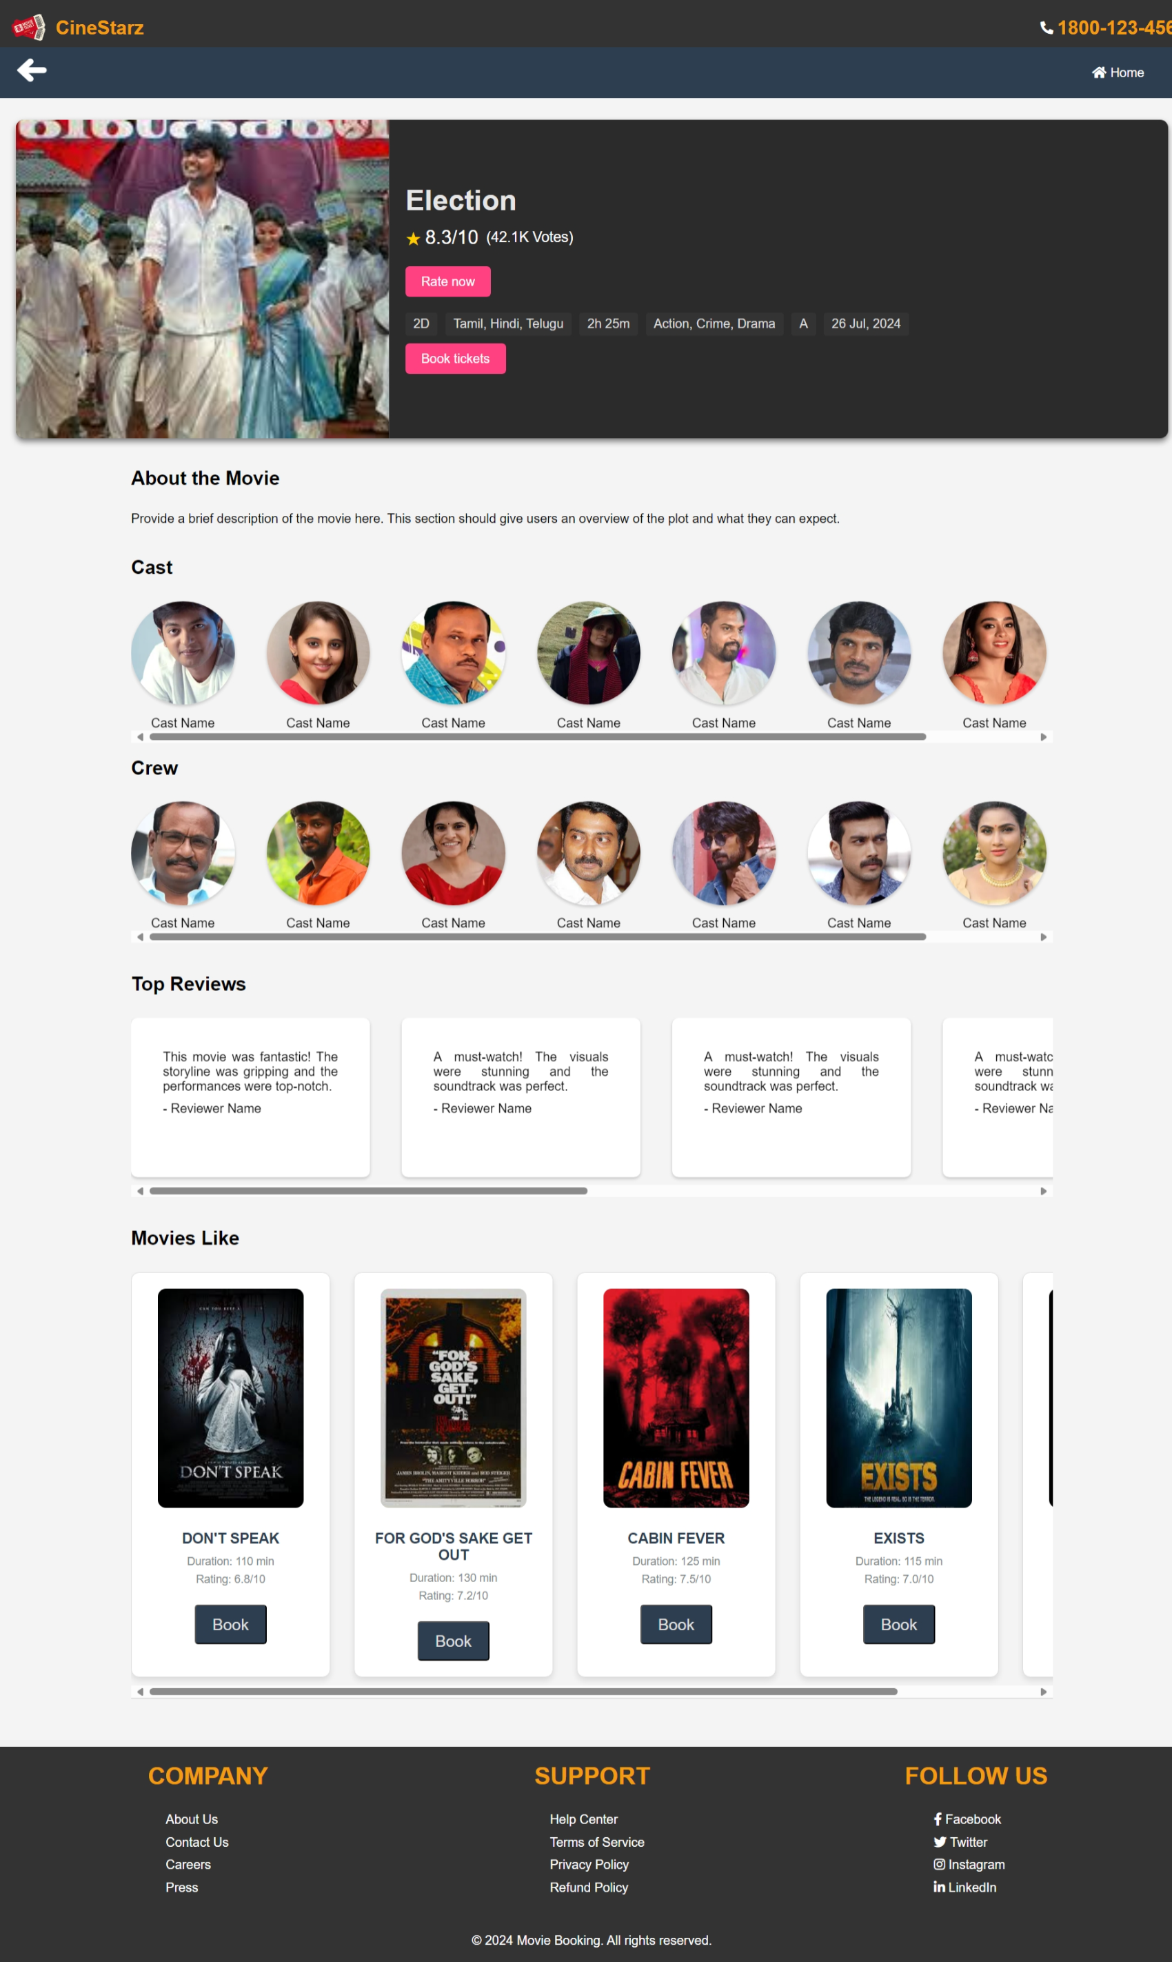

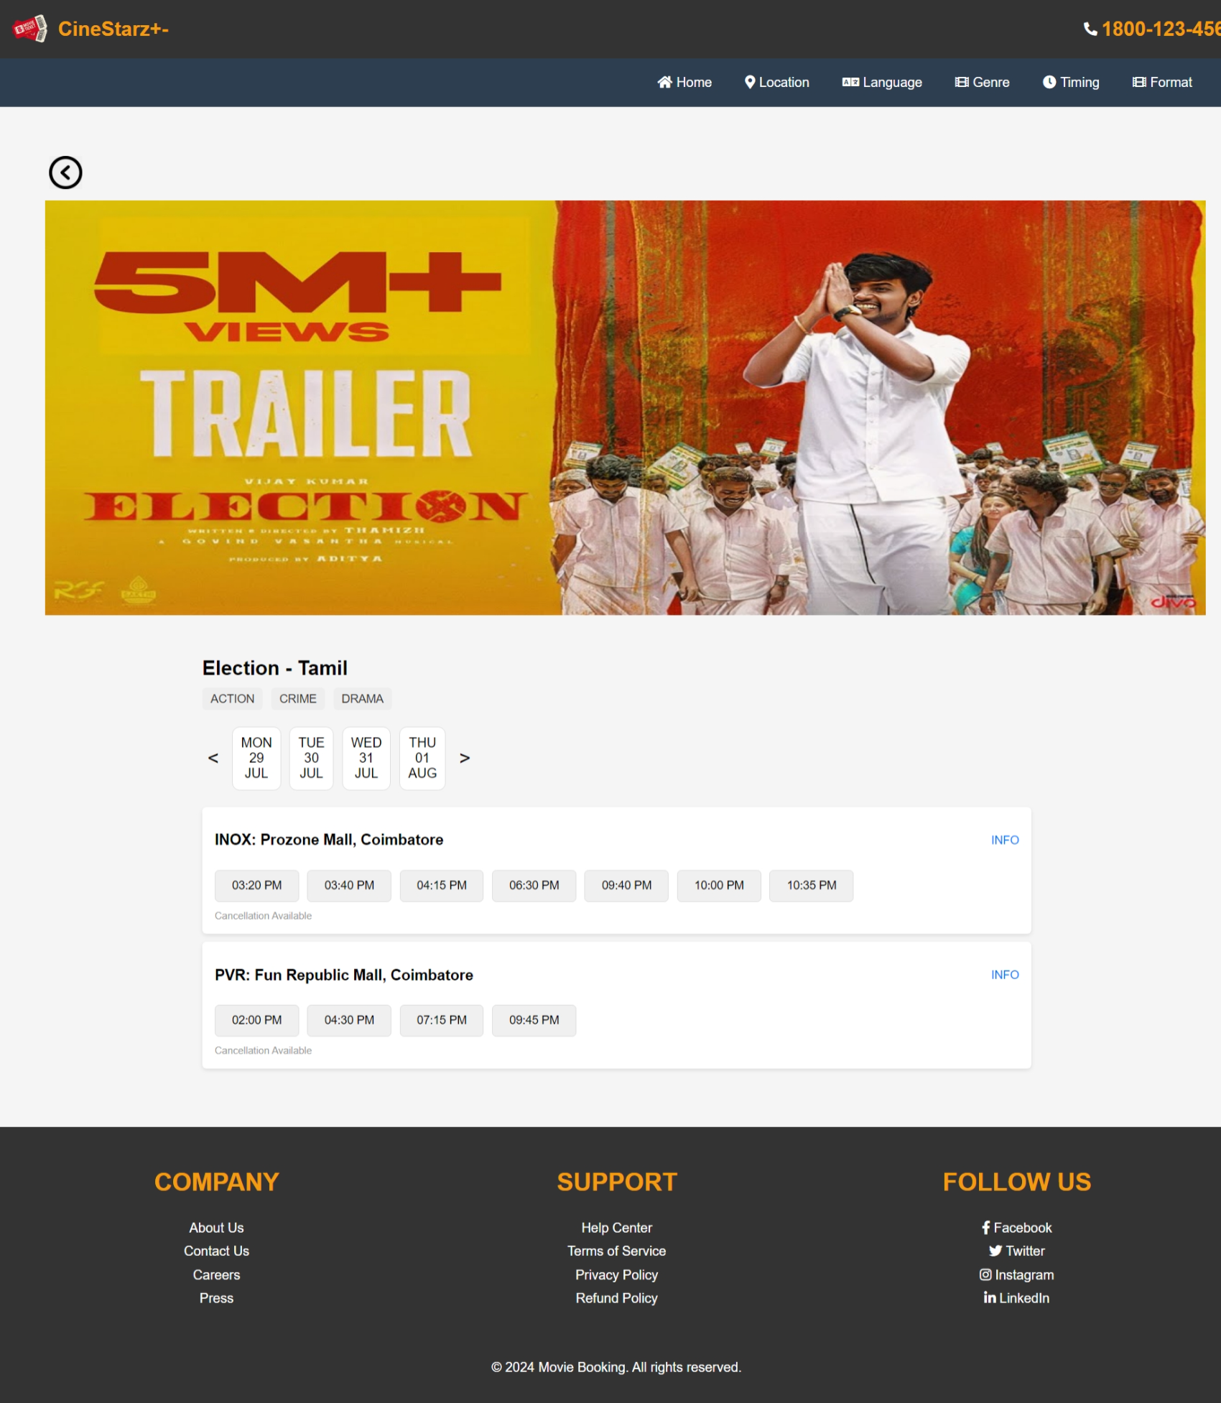

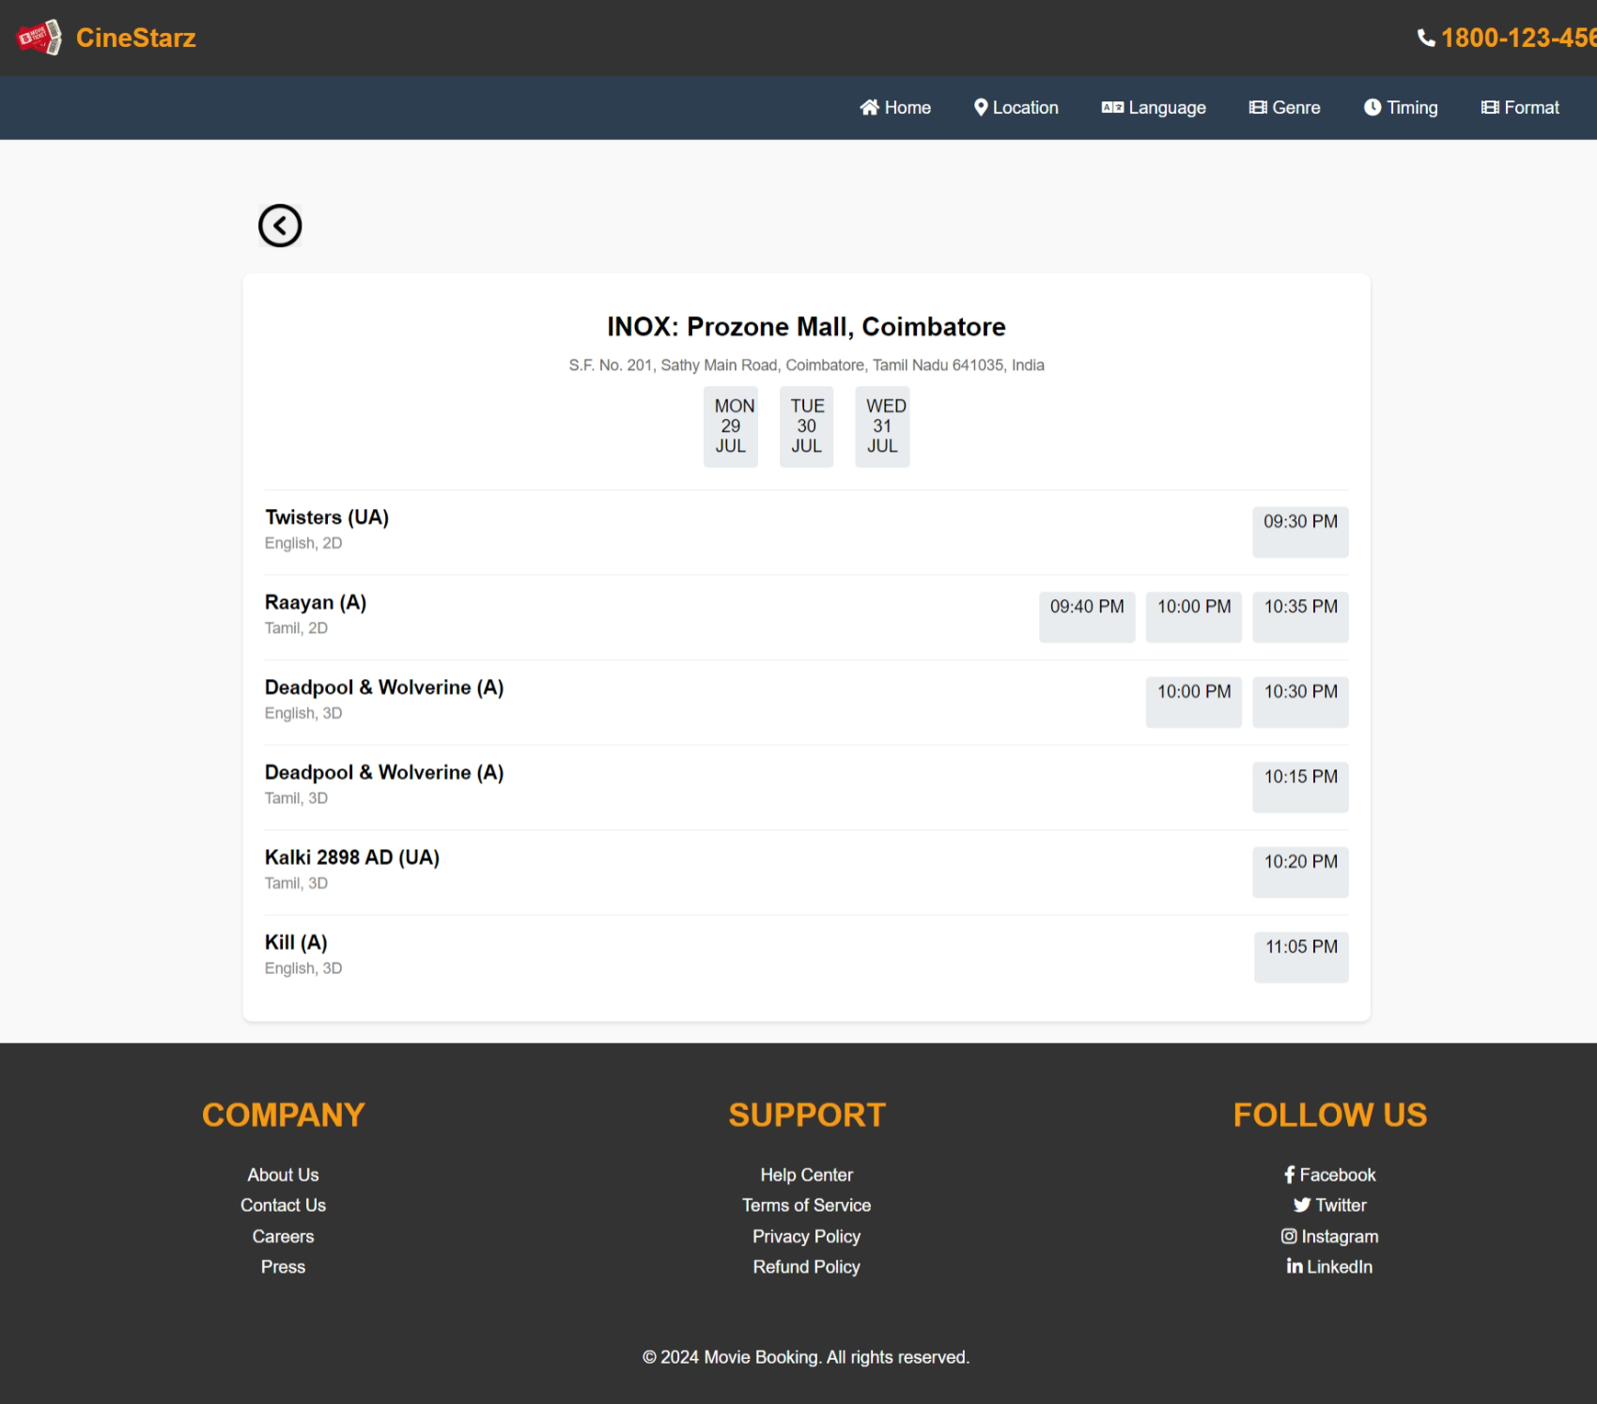

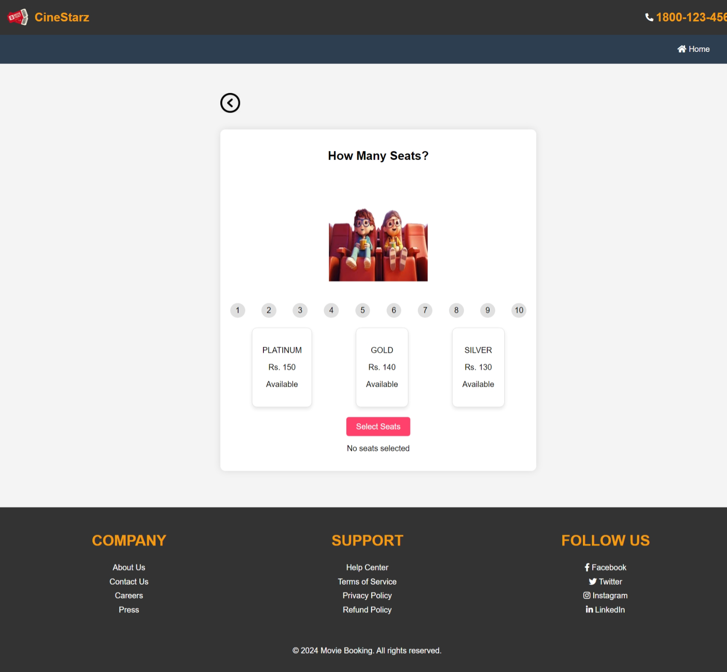

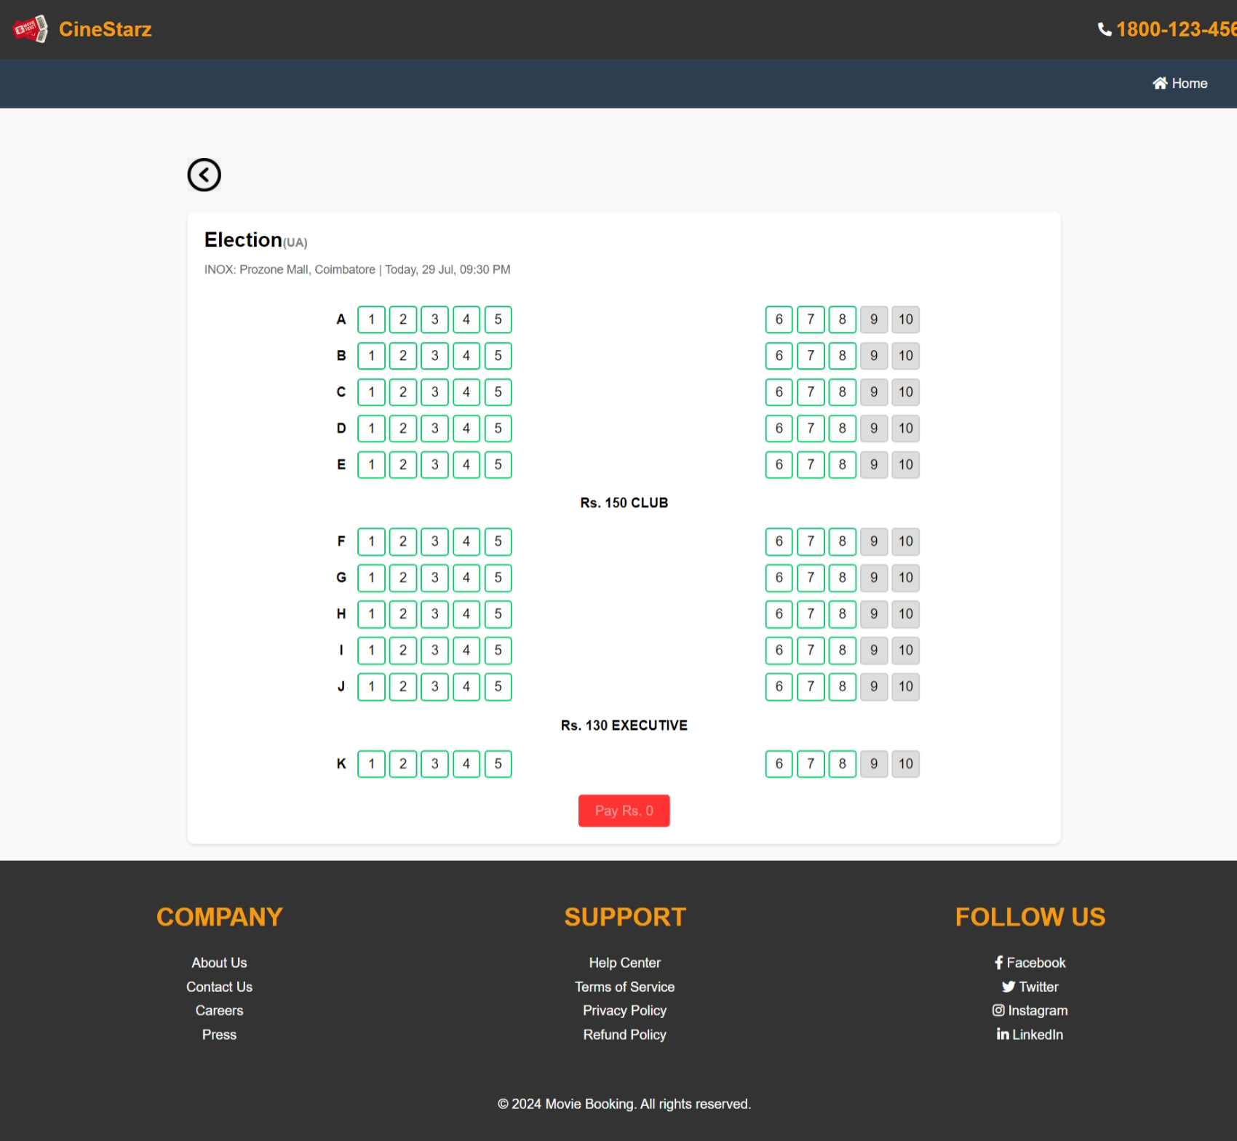

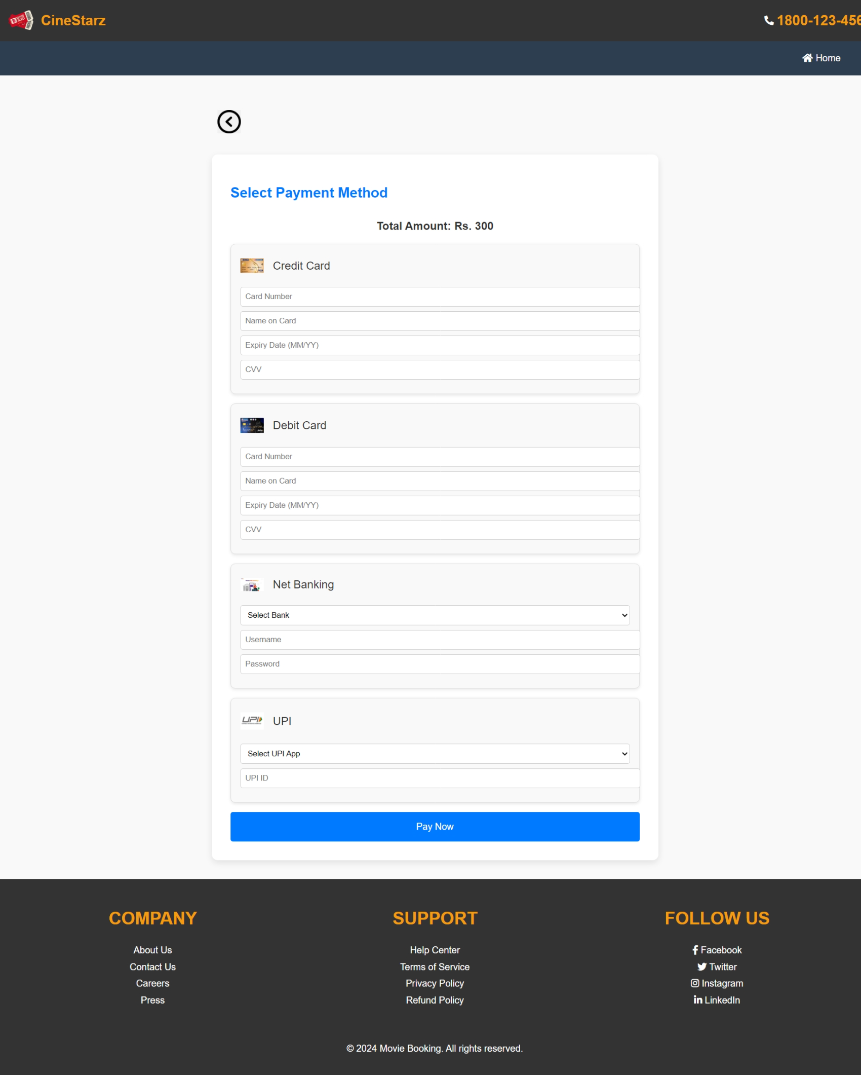

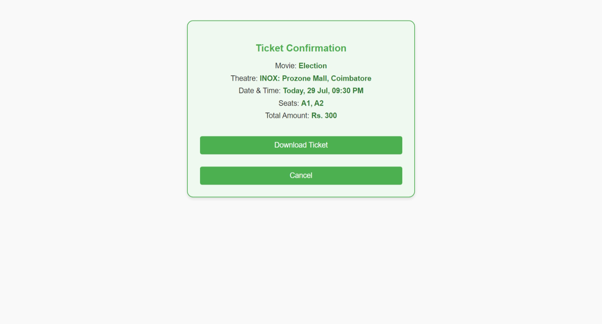

**CONCLUSION:**

Using this Application users can book the movie tickets in online, based on the filters such as location, language, timing, genre, format. The application gives the details of the movies such as cast, crew, reviews and enable the user to rate the movie based on their movie experience.

The admin can manage the movies which are shown to the users and they manage the landing page slideshow by updating the upcoming movies and do the add, update, view, delete operations and they can manage the bookings by updating and deleting the booking. The admin can manage the users and ensure that the user is active or inactive state and they manage the statistics of the total movies and the total number of users over time. The admin can change the setting and able to update the profile.